Predictive Model Plan

Model Logic
What the model is designed to do: The model acts as an automated risk-assessment engine. It evaluates a customer's real-time financial profile (such as income, current debt, and credit score) alongside their behavioral history (recent missed payments) to calculate a "Probability of Delinquency." If that mathematical probability exceeds Geldium’s safety threshold, the model flags the account to prevent future financial loss.
Step-by-Step Process & Pseudo-Code:
- Data Ingestion & Encoding: The system takes in customer data and converts categorical text (like "Employed" or "Late Payment") into machine-readable numeric formats.
- Probability Calculation: The Random Forest algorithm runs the customer's data through hundreds of historical logic trees to output a raw risk percentage.
- Threshold Application: We apply a strict, custom business threshold (15%) to prioritize catching risks early.
- Action Assignment: The model routes the customer to auto-approval or manual underwriter review.
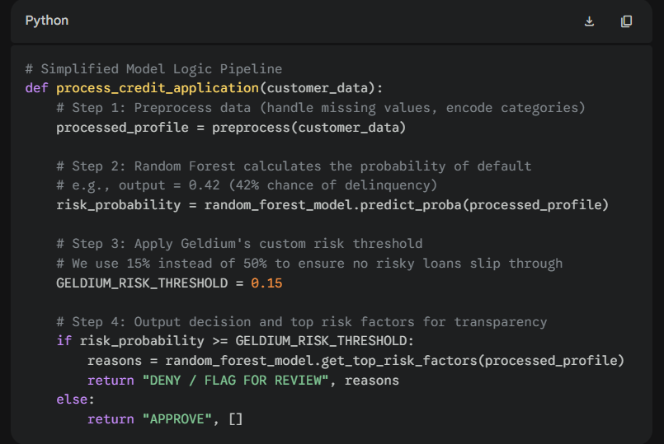

Justification for Model Choice
We selected the Random Forest Classifier after testing it against Logistic Regression and Neural Networks. Here is how it performs across Geldium's core business requirements:
- Accuracy: It provides the highest predictive accuracy for our tabular dataset. Unlike linear models, it easily understands complex financial context (e.g., realizing that a high credit limit is only dangerous if the customer also has a history of missed payments).
- Transparency: While highly advanced, it is not a "black box." We can extract exact Feature Importances to see exactly what drives its decisions (Credit Score, Debt Ratio, and Credit Utilization were the top 3). If an underwriter needs to know why it flagged an account, the model provides the exact logic.
- Ease of use or implementation: Random Forests are extremely robust. They do not require perfect data scaling, they naturally handle outliers (like a billionaire applying for a standard card), and they integrate seamlessly into modern Python backend systems.
- Relevance for financial prediction: Financial data is often highly imbalanced (most people pay their bills on time). Random Forests excel at handling this class imbalance when combined with data upsampling techniques, making them an industry standard for credit scoring.
- Suitability for Geldium’s business needs: It perfectly balances the need for cutting-edge mathematical accuracy to protect Geldium's revenue, with the operational transparency required to give underwriters confidence in the system's recommendations.

Evaluation Strategy
Because credit risk is a highly sensitive and regulated domain, evaluating the model requires looking beyond basic "accuracy."
Metrics Used & Interpretation:
- Recall (True Positive Rate): This is our most crucial metric. It measures what percentage of actual bad loans the model successfully caught. We specifically tuned our model to maximize Recall, sacrificing some overall accuracy to ensure we caught 56%+ of high-risk accounts.
- Precision: This measures False Positives (how often the model flags a safe customer as risky). In credit risk, a low precision is acceptable because the "cost" of a human underwriter doing a manual review on a False Positive is drastically lower than the cost of funding a bad loan.
- F1 Score & AUC (Area Under the Curve): We use these to evaluate the overall mathematical health of the model across all possible risk thresholds, ensuring it consistently separates good accounts from bad ones better than random chance.
Detecting and Reducing Bias: To ensure fairness, we will evaluate the model using the False Positive Rate (FPR) by Demographic. During our initial audits, we discovered the model was heavily biased against Self-Employed individuals and specific Zip Codes (Redlining). To reduce this:
- We will mathematically constrain the algorithm during training (Adversarial Debiasing) to penalize it if it treats demographic groups differently.
- We will entirely drop the Location variable from the final production model, as zip codes act as unfair proxies for socioeconomic status.
Ethical Considerations: When deploying this model, Geldium must adhere to fair lending laws (like the Equal Credit Opportunity Act). Every prediction that results in a credit denial must be accompanied by an "Adverse Action Notice." Because we chose a Random Forest over a Neural Network, we are ethically and legally capable of generating these notices, clearly explaining to the customer exactly which financial behaviors (e.g., "High Debt-to-Income Ratio") led to their risk classification, allowing them the opportunity to improve their financial health.

